**Computer Science Department**

**California State University, Fullerton**

CPSC 240-01 Computer Organization and Assembly Language

Final Exam

1:00 PM to 2:40 PM

Tuesday, May 14, 2024

Student Name:

Last 4 digits of ID:

**Note:**

* University regulations on academic honesty will be strictly enforced.
* You have 100 minutes to complete this Quiz.
* Open books, slides and sample programs.
* Turn off or turn vibration your cell phone.
* Use YASM assembler for the program design.
* Copy and paste your assembly source code and Terminal Emulator window to the end of the word file and save it in pdf or docx format.
* Submit you pdf or docx file to Canvas before the deadline.   
  NOTE: Email submissions will not be graded.
* Any content submitted after the due date will be regarded as a make-up exam.

1. Design an assembly program that reads 3 single digit from keyboard to variables (num1, num2, and num3), calculates “sum=num1+num2” and “quotient=sum/num3”, and displays the sum and quotient to the terminal.
2. The program needs to define “scan” and “print” macros for sys_read and sys_write, define “calculate” and “toString” functions for calculation and converting integer to ASCII for displaying.
3. When calling “scan” and “print” macros, the caller needs to pass the buffer address and number of characters. When calling the “calculate” function, the caller needs to pass num1, num2, num3, &sum, &quotient. When calling the “toString” function, the caller needs to pass &sum/&quotient and &ascii.
4. The following pseudo code provides students with a reference when writing assembly code. Students can directly convert the following pseudo code into assembly code.

;finalExam_01.asm

#begin define print(addr, n)

rax = 1;

rdi = 1;

rsi = addr of string;

rdx = n;

syscall;

#end

#begin define scan(&addr, n)

rax = 1;

rdi = 1;

rsi = &addr;

rdx = n;

syscall;

#end

char num1, num2, num3, sum, quotient;

char buffer[2];

char ascii[10];

char msg1[24] = "Input 1st number (0~9): ";

char msg2[24] = "Input 2nd number (0~9): ";

char msg3[24] = "Input 3rd number (0~9): ";

char msg4[6] = "sum = ";

char msg5[11] = "quotient = ";

void main() {

print msg1, 24;

scan buffer, 2

num1 = atoi(buf);

print msg2, 24;

scan buffer, 2

num2 = atoi(buf)

print msg3, 24;

scan buffer, 2

num3 = atoi(buf)

call calculate(num1, num2, num3, &sum, &quotient);

call toString(&sum, &ascii)

print msg4, 6;

print ascii, 4;

call toString(&quotient, &ascii)

print msg5, 11;

print ascii, 4;

}

void calculate(num1, num2, num3, &sum, &quotient) {

sum = num1 + num2;

if(num3 != 0)

quotient = sum / num3;

else

quitient = 0;

}

void toString(&argument, &ascii) {

ascii = itoa(argument);

}

1. After assembling and linking, run the executable file to display the simulation results in the Terminal Emulator window as the following example.
2. Insert source code and the simulation results (Terminal Emulator window) to the bottom of the document.
3. Save the file in pdf or docx format and submit the pdf or docx file to Canvas before the deadline.
4. Deadline is 2:40 pm on 5/14/2024.

Simulation result example:

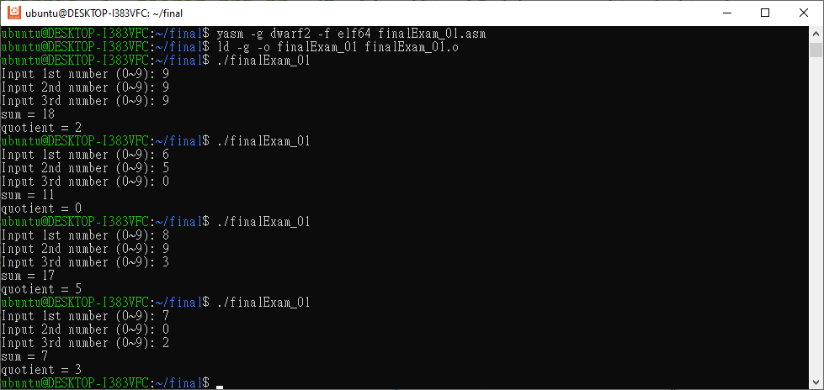

**Sample**

**Sample**

[Attach your assembly source code here:]

[Attach Terminal Emulator window here:]